IndiaFest 2022 – SPONSORSHIP/ADVERTISEMENT ORDER FORM
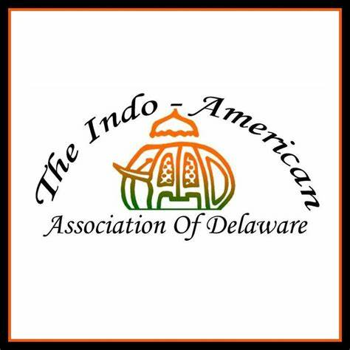
Saturday, September 17th – 12.00 PM to 8.00 PM
Christiana High School
190 Salem Church Road, Newark, DE 19713

Banner Advertising Rate
☐ Banner (Max: 6 sponsors) (Banner Size 2x8) $600

Yard Advertising (around School-only on Event day) Rate
☐ Yard Sign $50

Constant Day Off Advertising via Slideshow Rate
Rotating Slideshow Presentation on School Auditorium Screen
☐ Slide show (Max: 10 sponsors) $100

Facebook Advertisement on IAAD FB Page Rate
Advertisement running once a week from 8/17/2022-9/17/2022
☐ Slide show (Max: 10 sponsors) $100

Contact name:
Company name:
Email:
Phone:
Total amount: $ Special Instructions (if any):

Please make checks payable to IAAD and mail the check and the completed advertisement form to:
IAAD, 308 Bartram Lane East, Hockessin, DE 19707

Or

Pay online at http://iaadelaware.org/sponsors.html and email the completed advertisement form to iaadnews@gmail.com

Please e‐mail your advertisement file directly to iaadnews@gmail.com
(Banner ad file or Yard Sign ad file deadline: September, 3, 2022)
(Slideshow Advertising ad file deadline: September, 10, 2022)

Contact for any questions:
Rohan D’Souza: Tel: 302‐521‐0218 (cell), Email: rohandd@gmail.com
Michael Iqbal: Tel: 302-753-8940 (cell), Email: michaeliqbal@gmail.com

